<http://courses.cs.tamu.edu/bart/cpsc410/Supplements/Slides/page-rep3.pdf>

<https://www.quora.com/Can-anyone-give-the-detailed-algorithm-of-enhanced-second-chance-algorithm>

<https://www.geeksforgeeks.org/second-chance-or-clock-page-replacement-policy/>

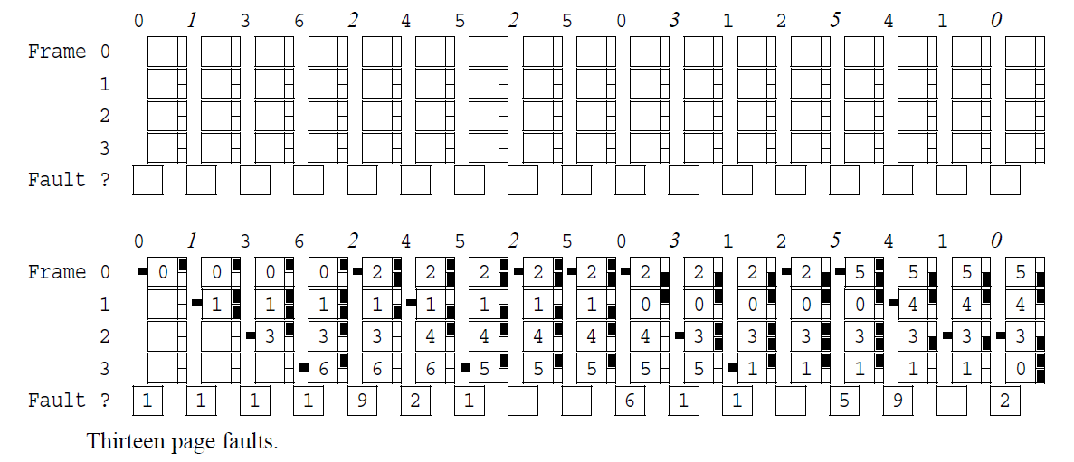

0 1 3 6 / 2 4 5 2 5 0 3 1 2 5 4 1 0

